Parkview Services for Seniors

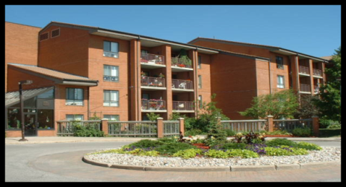

Rental Accommodation
Parkview Village Apartments
12184 Ninth Line
- 90 one bedroom and 34 two bedroom apartments, completed in 1986.
- $1150/month + Program, Amenity & Wellness Center fees, for a 544 sq. ft. one bedroom apartment
- $1414/m + program, amenity & Wellness Center fees, for a 781 sq. ft. 2 bedroom apartment.
A mandatory monthly charge of $29.70 (Amenity fee) per unit, $21.82 per person (Program fee) and $22.00 per person (Wellness Center fee) per month is added to the monthly rent or operating/maintenance fees to fund these services. Apartment parking spaces are $21.82/month.

- 6 apartments are accessible units to accommodate residents with physical disabilities.
- Each year York Region determines the rental increase.
- Some one bedroom apartments are offered with rent-geared-to-income subsidies. Tenants receiving this subsidy pay approximately 30% of the total household income for rent.

Application/Waiting List Information:

Application/Waiting List Information:
Parkview Housing application forms are available at the information desk at the Parkview Village office. Forms are also available online at www.parkviewhome.ca
Once the completed application is received, the applicants’ name is added to the wait list.
York Region Subsidy application forms are available through the website of York.ca, and should be mailed directly to York Region.

Parkview Village Programs

The Program Coordinator organizes a full calendar of activities including; fitness classes, bus trips, social events and wellness information sessions. Evening events include games such as; bridge, cribbage, dominoes, shuffleboard and euchre.For more information on programs, please call 905-640-1940 ext. 2024.

Gardenview Village Café
The Café is open to tenants and guests for lunch 6 days a week from 12 noon to 1:30

pm. The Café offers a variety of healthy food choices. Social hour is enjoyed between 10am-11am and 2pm-3pm.

Parkview Village Centre
The Village Centre is a unique facility connecting the suites and the apartment building. Residents enjoy a range of amenities and services, including:
~Community Auditorium~
Wellness Centre
~Balconies or patios Fitness Centre
~Gardenview Café ~ Hair Stylist
~Spacious leisure spaces ~Foot care
~Craft Room ~Library
~Garden & Solarium slots Tuck Shop
~Fountain & Garden Paths ~Atrium
~Bible Study ~Quilting Room

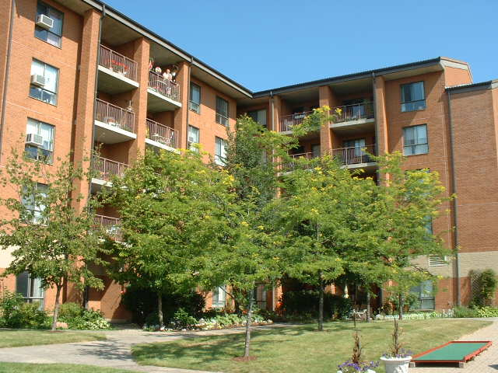

Parkview Village Housing & Administration office:
Tel: 905-640-1940 ext 2023
Email: bclayton@parkviewvillage.ca

Website: www.parkviewhome.ca

Parkview Services for Seniors

Is a partnership of three Ontario
Non-Profit Corporations.
The Mennonite Home Association of York County was formed in 1964 to meet the need for long term care and accommodation for older persons, and currently operates Parkview Home.

Parkview Village Retirement Community
Association of York Region was formed in 1984, to operate the Parkview Village
Retirement Community, a rental apartment building which provides senior’s independent living and partnered supportive services.

Finally, in 1989, Parkview Village Cluster Homes for Seniors Association of York
Region was formed to provide an
independent living environment in resident financed Cluster Homes and Suites through a “Right to Occupy” agreement.

Mission
Motivated by our Christian faith and
Mennonite heritage, the mission
of Parkview Services for Seniors
*Serve Seniors is to:
*Nurture Community
*Honour Aging

Vision
Our campus will be the most sought-after hub of community services and housing for older adults in York Region because where you age matters!
Rev.June 2021

