Parkview Services for Seniors

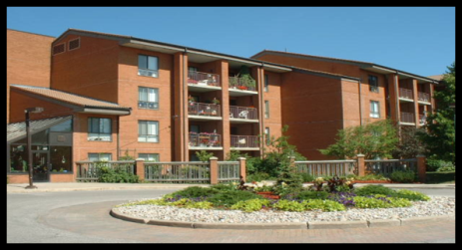

Life-Lease Accommodation
Lifelease housing is an alternative option for older adults who live independently and are looking to move into a smaller home. Through a contractual agreement, the purchaser makes a capital contribution in exchange for the right to occupy a lifelease unit. Monthly Operating fees are paid to cover property taxes, building maintenance and in-suite repairs.

What does right to occupy mean?

In life lease housing, you do not own the property, you hold an interest in that property. The life lease interest gives you the right to occupy or live in a unit until you wish to sell. When the unit is being sold, it is reevaluated at current market value. Should the resident pass away, the executor receives the funds from the sale, but is not entitled to the right to occupy agreement.

Please contact Parkview Housing for current pricing and unit styles offered.

Reasons why people choose life lease housing include:

To benefit from fewer home maintenance responsibilities, such as mowing lawns, shovelling snow, maintaining furnaces, plumbing leaks, appliance malfunctions or electrical repairs.
To enjoy social and recreational programs offered by the facility, with a sense of community.
To purchase an affordable lifelease suite or bungalow unit instead of a higher costs condominium in the community.
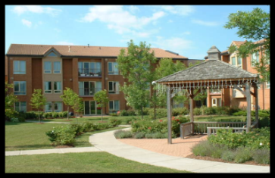

Parkview Suites
12140 Ninth Line

- Parkview offers 45 apartment style suites units
- Completed in 1997.
- Sizes range from 861 to 1824 square feet.
- Applicable Monthly operating fees apply and are dependent on size of the unit as well as facility fees paid by all residents at Parkview such as:
- Program, Amenity & Wellness Center.
- Appliances & gas fireplaces included.
- One underground parking space is included.
- Parkview is responsible for water utility.
- Lifelease Residents are responsible to pay for their metered services, such as gas or hydro as well as their television, telephone, and internet services.

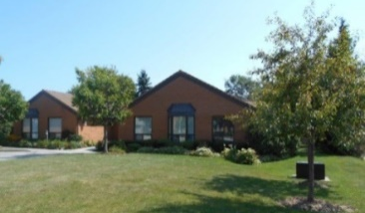

Parkview Clusters
12132 Ninth Line
- 20 bungalow-style units.
- Constructed in the late eighties.
- From 690 to 1170 square feet in size.
- Applicable Monthly operating fees apply and are dependent on size of unit as well as facility fees paid by all residents at Parkview such as:
- Program, Amenity & Wellness Center.
- Appliances, and gas fireplaces is included.
- One garage space is included.
- Parkview is responsible for water utility.
- Lifelease Residents are responsible to pay for their metered services, such as gas or hydro as well as their television, telephone, and internet services.

Parkview Village Programs

The Program Coordinator organizes a full calendar of activities including; fitness classes, bus trips, social events and wellness information sessions. Evening events include games such as; bridge, cribbage, dominoes, shuffleboard and euchre. For information on programs, please call 905-640-1940 ext. 2024.

Gardenview Village Café

The Café is open to tenants and guests for lunch 6 days a week from 12 noon to 1:30 pm. The Café offers a variety of healthy food choices. Social hour is enjoyed between 10am-11am and 2pm-3pm.

Parkview Village Centre

The Village Centre is a unique facility connecting the suites and the apartment building. Residents enjoy a range of amenities and services, including:
~Community Auditorium~
Wellness Centre
~Balconies or patios Fitness Centre
~Gardenview Café ~ Hair Stylist
~Spacious leisure spaces ~Foot care
~Craft Room ~Library
~Garden & Solarium slots Tuck Shop
~Fountain & Garden Paths ~Atrium
~Bible Study ~Quilting Room

Parkview Village Housing & Administration offices:
905-640-1940 ext 2023
By email: bclayton@parkviewvillage.ca
Website: www.parkviewhome.ca
rev.June 2021

Parkview Services for Seniors

Is a partnership of three Ontario
Non-Profit Corporations.

The Mennonite Home Association of York County was formed in 1964 to meet the need for long term care and accommodation for older persons, and currently operates Parkview Home.

Parkview Village Retirement Community
Association of York Region was formed in 1984, to operate the Parkview Village
Retirement Community, a rental apartment building which provides senior’s independent living and partnered supportive services.

Finally, in 1989, Parkview Village Cluster Homes for Seniors Association of York
Region was formed to provide an
independent living environment in resident financed Cluster Homes and Suites through a “Right to Occupy” agreement.

Mission
Motivated by our Christian faith and
Mennonite heritage, the mission
of Parkview Services for Seniors is to:
*Serve Seniors
*Nurture Community
*Honour Aging

Vision
Our campus will be the most sought-after hub of community services and housing for older adults in York Region because where you age matters!

Parkview Long Term Care Home
123 Weldon Road
Residents and staff moved to our new building at 123 Weldon Road in September 2006. Our 128 bed long term care home is fully accredited. PV home is regulated by the MOHLTC.

Parkview home prides itself in its excellent

There are 128 beds; 76 private and 26 basic (2 person) rooms in 5 Resident Home Areas (RHA), named to honour our environment, nature and Parkview’s heritage. Each RHA has its own dining room, sitting room and activity rooms.

Parkview Home provides 24 hour nursing care and medical care provided by 3 local physicians and a nurse practitioner. Other services include restorative care, stimulating leisure/activity programs, social support and spiritual comfort provided by our on-site Social Service Worker and Chaplain.

Admission to the Home is facilitated through CLHIN at 1-888-470-2222.

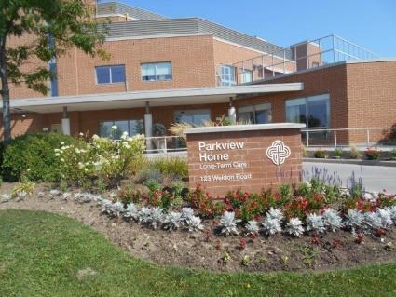
Parkview Long Term Care
At Parkview Home our focus is our residents.
Resident care includes:
Nursing Care
- Residents live in the Resident Home Area which is most closely suited to their care needs.
- Personal care is provided in each area by Personal Support Workers, Registered Practical Nurses and Registered Nurses.
- On-Site clinics (charges may apply) include chiropody, optometry, hearing and dental service.
- Specialty services (charges may apply) are provided on site through our service partners including: pharmacy, physiotherapy, occupational therapy, lab services, x-ray, oxygen therapy, hairdressing/barbering and foot care.

Nutritional Services
- Nutritionally balanced menus offer 2 choices at each meal and menus change seasonally.
- Dietary needs of each Resident are monitored by a Registered Dietitian.
- Special occasion meals available.

Leisure Activity & Restorative Therapy
- Daily activities geared to the needs and interests of the Residents in each Home Area.
- Contract physiotherapist on site.
- Restorative care therapy.
- Music therapy and Memory Program.
- Pet therapy.
- Multi-faith spiritual services delivered by our own Chaplain and many local community churches.
- Art Therapy.
Environmental Services
- Housekeeping, laundry and maintenance services.

Parkview Home Administrative Offices:
Parkview Home 905-640-1911 x 1221
Website: www.parkviewhome.ca
Follow us on Facebook:
Parkview Services for Seniors

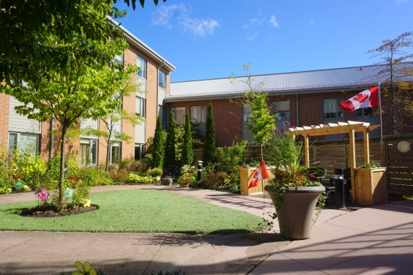

Parkview Services for Seniors
Is a partnership of three Ontario
Non-Profit Corporations.
The Mennonite Home Association of York County was formed in 1964 to meet the need for long term care and accommodation for older persons, and currently operates Parkview Home.

Parkview Village Retirement Community
Association of York Region was formed in 1984, to operate the Parkview Village
Retirement Community, a rental apartment building which provides senior’s independent living and partnered supportive services.

Finally, in 1989, Parkview Village Cluster Homes for Seniors Association of York
Region was formed to provide an
independent living environment in resident financed Cluster Homes and Suites through a “Right to Occupy” agreement.

Mission
Motivated by our Christian faith and
Mennonite heritage, the mission
of Parkview Services for Seniors is to:
*Serve Seniors
*Nurture Community
*Honour Aging

Vision
Our campus will be the most sought-after hub of community services and housing for older adults in York Region because where you age matters!

Revised Feb 2021

