Parkview Services for Seniors
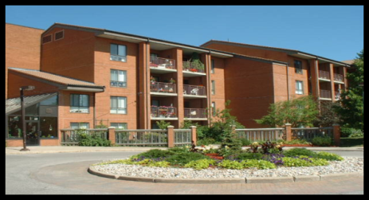

Rental Accommodation
Parkview Village Apartments
12184 Ninth Line
- 90 one bedroom and 34 two bedroom apartments, completed in 1986.
- $1150/month + Program, Amenity & Wellness Center fees, for a 544 sq. ft. one bedroom apartment
- $1414/m + program, amenity & Wellness Center fees, for a 781 sq. ft. 2 bedroom apartment.
A mandatory monthly charge of $29.70 (Amenity fee) per unit, $21.82 per person (Program fee) and $22.00 per person (Wellness Center fee) per month is added to the monthly rent or operating/maintenance fees to fund these services. Apartment parking spaces are $21.82/month.

- 6 apartments are accessible units to accommodate residents with physical disabilities.
- Each year York Region determines the rental increase.
- Some one bedroom apartments are offered with rent-geared-to-income subsidies. Tenants receiving this subsidy pay approximately 30% of the total household income for rent.

Application/Waiting List Information:
Application/Waiting List Information:
Parkview Housing application forms are available at the information desk at the Parkview Village office. Forms are also available online at www.parkviewhome.ca
Once the completed application is received, the applicants’ name is added to the wait list.
York Region Subsidy application forms are available upon request and should be mailed directly to York Region.

Life-Lease Accommodation
Life-lease is a contractual agreement where the resident makes an initial capital contribution in exchange for the right to occupy a cluster or suite. Monthly Operating fees are paid to cover property taxes, building maintenance and in-suite repairs. When the unit is being sold, it is re-evaluated at current market value.
Parkview Suites
12140 Ninth Line
- 45 apartment style units
- Completed in 1997.
- From 861 to 1824 square feet in size.
- Operating fees from $861 to $1204/month + Program, Amenity & Wellness Center Fees.
- Appliances & gas fireplaces included.
Residents are responsible to pay for applicable metered services, such as gas or hydro as well as their television, telephone etc. Appliances, and underground parking is included. Parkview is responsible for water utilities.

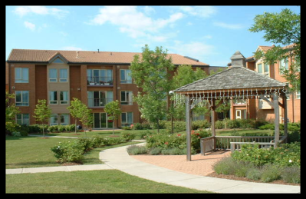

Parkview Clusters
12132 Ninth Line
- 20 bungalow-style units.
- Constructed in the late eighties.
- From 690 to 1170 square feet in size.
- Operating fees from $663 to $847/month + Program, Amenity & Wellness Center Fees.
- Appliances, gas fireplaces & garage space is included.

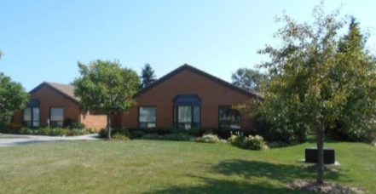
Parkview Village Programs
The Program Coordinator organizes a full calendar of activities including; fitness classes, bus trips, social events and wellness information sessions. Evening events include games such as; bridge, cribbage, dominoes, shuffleboard and euchre.For more information on programs, please call 905-640-1940 ext. 2024.

Gardenview Village Café
The Café is open to tenants and guests for lunch 6 days a week from 12 noon to 1:30 pm. The Café offers a variety of healthy food choices. Social hour is enjoyed between 10am-11am and 2pm-3pm.
Parkview Village Centre
The Village Centre is a unique facility connecting the suites and the apartment building. Residents enjoy a range of amenities and services, including:
~Community Auditorium ~ Wellness Centre
~Balconies or patios ~Fitness Centre
~Gardenview Café ~ Hair Stylist
~Spacious leisure spaces ~Foot care
~Craft Room ~Library
~Garden & Solarium slots ~Tuck Shop
~Fountain & Garden Paths ~Atrium
~Bible Study ~Quilting Room
Parkview Village Wellness Center
The Wellness Center is intended to address service gaps for healthy aging. It provides scheduled and unscheduled medical services with a family doctor from Stouffville Medical Clinic, who comes to the Center. The Wellness Coordinator assists tenants by navigating health and personal care services.
For more information on the Center, please call 905-640-1940 ext. 2037.

Parkview Village Housing Office & Administration:
905-640-1940 ext 2023
Website: www.parkviewhome.ca
Follow us on Facebook:
Parkview Services for Seniors
Parkview Long Term Care Home
123 Weldon Road
Residents and staff moved to our new building at 123 Weldon Road in September 2006. Our 128 bed long term care home is fully accredited. PV home is regulated by the MOHLTC.

Parkview home prides itself in its excellent

There are 128 beds; 76 private and 26 basic (2 person) rooms in 5 Resident Home Areas (RHA), named to honour our environment, nature and Parkview’s heritage. Each RHA has its own dining room, sitting room and activity rooms.

Parkview Home provides 24 hour nursing care and medical care provided by 3 local physicians and a nurse practitioner. Other services include restorative care, stimulating leisure/activity programs, social support and spiritual comfort provided by our on-site Social Service Worker and Chaplain.

Admission to the Home is facilitated through CLHIN at 1-888-470-2222.

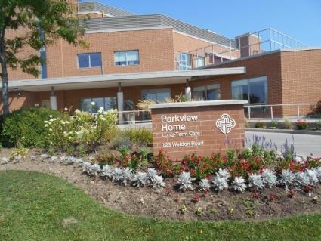

Parkview Long Term Care
At Parkview Home our focus is our residents.
Resident care includes:
Nursing Care
- Residents live in the Resident Home Area which is most closely suited to their care needs.
- Personal care is provided in each area by Personal Support Workers, Registered Practical Nurses and Registered Nurses.
- On-Site clinics (charges may apply) include chiropody, optometry, hearing and dental service.
- Specialty services (charges may apply) are provided on site through our service partners including: pharmacy, physiotherapy, occupational therapy, lab services, x-ray, oxygen therapy, hairdressing/barbering and foot care.

Nutritional Services
- Nutritionally balanced menus offer 2 choices at each meal and menus change seasonally.
- Dietary needs of each Resident are monitored by a Registered Dietitian.
- Special occasion meals available.

Leisure Activity & Restorative Therapy
- Daily activities geared to the needs and interests of the Residents in each Home Area.
- Contract physiotherapist on site.
- Restorative care therapy.
- Music therapy and Memory Program.
- Pet therapy.
- Multi-faith spiritual services delivered by our own Chaplain and many local community churches.
- Art Therapy.
Environmental Services
- Housekeeping, laundry and maintenance services.
Parkview Services for Seniors
Is a partnership of three Ontario
Non-Profit Corporations.
The Mennonite Home Association of York County was formed in 1964 to meet the need for long term care and accommodation for older persons, and currently operates Parkview Home.

Parkview Village Retirement Community
Association of York Region was formed in 1984, to operate the Parkview Village
Retirement Community, a rental apartment building which provides senior’s independent living and partnered supportive services.

Finally, in 1989, Parkview Village Cluster Homes for Seniors Association of York
Region was formed to provide an
independent living environment in resident financed Cluster Homes and Suites through a “Right to Occupy” agreement.

Mission
Motivated by our Christian faith and
Mennonite heritage, the mission
of Parkview Services for Seniors is to:
*Serve Seniors
*Nurture Community
*Honour Aging

Vision
Our campus will be the most sought-after hub of community services and housing for older adults in York Region because where you age matters!

Revised Feb 2020
Parkview Home Administrative Offices:
Parkview Home 905-640-1911 x 1221
Website: www.parkviewhome.ca
Follow us on Facebook:
Parkview Services for Seniors

